Hamza Salahuddin
Lab-04
Q1
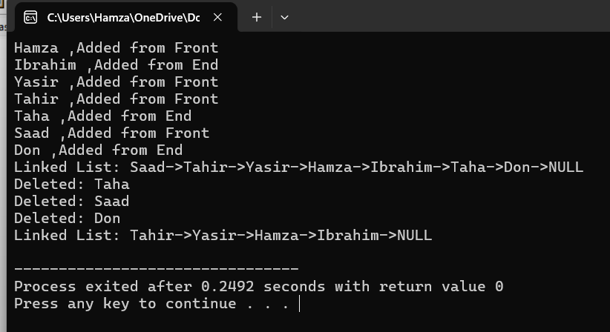
#include<iostream>
#include<cstring>
using namespace std;
class Node{
public:
string name;
Node* next;

Node(){
this->name="";
this->next=NULL;
}
Node(string name){
this->name=name;
this->next=NULL;
}
};
Node* head=NULL;
Node* tail=NULL;

void AddFromFront(string name){
Node* n=new Node(name);
n->next=head;
head=n;
cout<<name<<" ,Added from Front"<<endl;
}

void AddFromEnd(string name){
Node* n=new Node(name);
if(head==NULL){
head=n;
return;
}
Node* temp=head;
while(temp->next!=NULL){
temp=temp->next;
}
temp->next=n;
cout<<name<<" ,Added from End"<<endl;
}

void DeleteByValue(string name){
if(head==NULL){
cout<<"List is empty"<<endl;
return;
}
Node* curr=head;
Node* pre;
if(head->name==name){
curr=head;
head=head->next;
delete curr;
cout<<"Deleted: "<<name<<endl;
return;
}
while(curr->next!=NULL && curr->name!=name){
pre=curr;
curr=curr->next;
}
if (curr==NULL){
cout<<"Value not found"<<endl;
return;
}
pre->next=curr->next;
delete curr;
cout<<"Deleted: "<<name<<endl;

}
void DeleteFromFront(){
if(head==NULL){
cout<<"Nothing in the list(From front function)"<<endl;
return;
}
Node* temp=head;
cout<<"Deleted: "<<temp->name<<endl;
head=head->next;
delete temp;
}
void DeleteFromEnd(){
if (head==NULL) {
cout<<"Nothing in the list (from end function)" << endl;
return;
}
if (head->next==NULL) {
delete head;
head=NULL;
return;
}

Node* temp=head;
Node* pre;
if(head==NULL){
cout<<"Nothing in the list(from end function)";
}
while(temp->next!=NULL){
pre=temp;
temp=temp->next;
}
tail=pre;
cout<<"Deleted: "<<temp->name<<endl;
tail->next=NULL;
delete temp;
}
void Display() {
if (head==NULL){
cout<<"Linked List is empty." << endl;
return;
}
Node* temp=head;

cout<<"Linked List: ";
while(temp!=NULL) {
cout<<temp->name<<"->";
temp=temp->next;
}
cout<<"NULL"<<endl;
}

int main(){
AddFromFront("Hamza");
AddFromEnd("Ibrahim");
AddFromFront("Yasir");
AddFromFront("Tahir");
AddFromEnd("Taha");
AddFromFront("Saad");
AddFromEnd("Don");

Display();

DeleteByValue("Taha");
DeleteFromFront();
DeleteFromEnd();

Display();

}

Q2
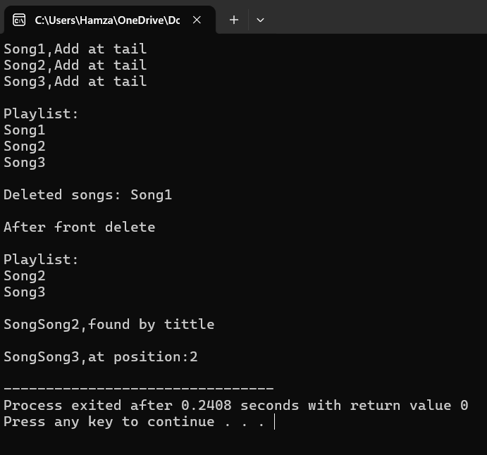
#include<iostream>
#include<cstring>
using namespace std;

class Node{
public:
string title;
Node* next;
Node(string title){
this->title=title;
this->next=NULL;
}
};
Node* head=NULL;

void addSong(string title){
Node* n=new Node(title);
if(head==NULL){
head=n;
}else{
Node* temp=head;
while(temp->next!=NULL){
temp=temp->next;
}
temp->next=n;
}
cout<<title<<",Add at tail"<<endl;

}

void deleteFront(){
if(head==NULL){
cout<<"Playlist in empty"<<endl;
return;
}
Node* temp=head;
cout<<"\nDeleted songs: "<<temp->title<<endl;
head=head->next;
delete temp;
}

void searchByTitle(string title){
Node* temp =head;
while(temp!=NULL){
if(temp->title==title){
cout<<"\nSong"<<title<<",found by tittle "<<endl;
return;
}
temp=temp->next;
}
cout<<"Song"<<title<<",notfound "<<endl;

}
void searchByPosition(int p){
Node* temp=head;
int count=1;
while(temp!=NULL){
if(count==p){
cout<<"\nSong"<<temp->title<<",at position:"<<p<<endl;
return;
}
temp = temp->next;
count++;
}
cout<<"Song not found at this position"<<endl;
}
void display(){
if(head==NULL){
cout<<"\nPlaylist is empty"<<endl;
return;
}
Node* temp=head;
cout<<"\nPlaylist:"<<endl;
while(temp!=NULL){
cout<<temp->title<<endl;
temp=temp->next;
}
}
int main(){
addSong("Song1");
addSong("Song2");
addSong("Song3");
display();
deleteFront();
cout<<"\nAfter front delete"<<endl;
display();
searchByTitle("Song2");
searchByPosition(2);
return 0;
}

Q3
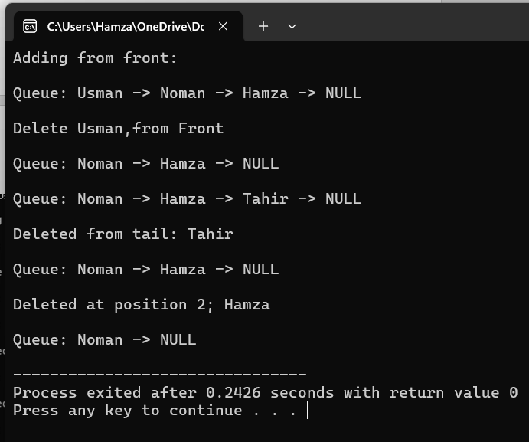
#include<iostream>
#include<string>
using namespace std;
class Node{
public:
string name;
Node* next;

Node(string n) {
name=n;
next=NULL;
}
};
Node* head=NULL;

void addFront(string name){
Node* temp=new Node(name);
temp->next=head;
head=temp;
}
void addTail(string name){
Node* newnode=new Node(name);
if(head==NULL){
head=newnode;
return;
}
Node* temp=head;
while(temp->next!=NULL){
temp=temp->next;
}
temp->next=newnode;
}
void deleteFront(){
if(head==NULL){
cout<<"Queue is empty"<<endl;
return;
}
Node* temp=head;
cout<<"\nDelete "<<temp->name<<",from Front"<<endl;
head=head->next;
delete temp;
}

void deleteTail(){
if(head==NULL){
cout<<"Queue is empty "<<endl;
return;
}
if(head->next==NULL){
cout << "\nDeleted from tail:"<<head->name<<endl;
delete head;
head = NULL;
return;
}
Node* temp = head;
while (temp->next->next != NULL) {
temp = temp->next;
}
cout <<"\nDeleted from tail: " << temp->next->name << endl;
delete temp->next;
temp->next = NULL;
}
void deleteAtPosition(int p) {
if(head==NULL) {
cout<<"Queue is empty"<<endl;
return;
}
if (p==1) {
deleteFront();
return;
}
Node* temp=head;
for (int i=1;temp!=NULL && i<p-1;i++) {
temp=temp->next;
}
if(temp==NULL || temp->next==NULL) {
cout<<"Invalid position"<<endl;
return;
}
Node* toDelete=temp->next;
cout<<"\nDeleted at position "<<p<<"; "<<toDelete->name<<endl;
temp->next = toDelete->next;
delete toDelete;
}

void display() {
Node* temp = head;
cout << "\nQueue: ";
while (temp != NULL) {
cout << temp->name << " -> ";
temp = temp->next;
}
cout << "NULL" << endl;
}

int main() {
cout<<"Adding from front: "<<endl;
addFront("Hamza");
addFront("Noman");
addFront("Usman");

display();

deleteFront();
display();

addTail("Tahir");
display();
deleteTail();
display();

deleteAtPosition(2);
display();
}

Q4
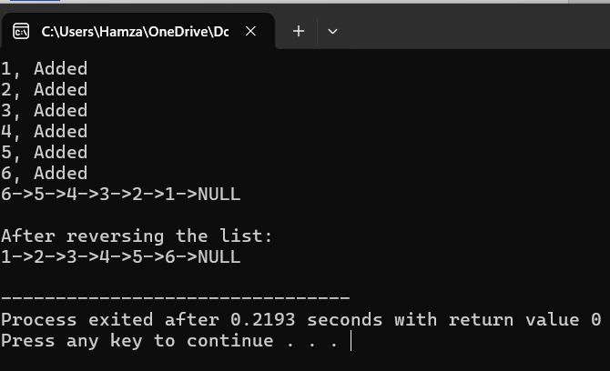
#include<iostream>
using namespace std;
class Node{
public:
int data;
Node* next;

Node(){
data=0;
next=NULL;
}
Node(int value){
data=value;
next=NULL;
}
};
Node* head=NULL;
Node* tail=NULL;

void InsertByValue(int value){
Node* newNode=new Node(value);
newNode->next=head;
head=newNode;
cout<<value<<", Added"<<endl;
}

void ReverseList(){
Node* pre=NULL;
Node* next=NULL;
Node* curr=head;
while(curr!=NULL){
next=curr->next;
curr->next=pre;
pre=curr;
curr=next;
}
head=pre;
}
void display(){
Node* temp=head;
while(temp!=NULL){
cout<<temp->data<<"->";
temp=temp->next;
}
cout<<"NULL"<<endl;
}

int main(){
InsertByValue(1);
InsertByValue(2);
InsertByValue(3);
InsertByValue(4);
InsertByValue(5);
InsertByValue(6);

display();
ReverseList();
cout<<"\nAfter reversing the list: "<<endl;
display();
}
Q5
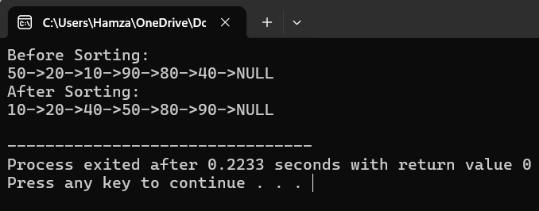
#include<iostream>
using namespace std;

class Node{
public:
Node* next;
int data ;

Node(int value){
data=value;
next=NULL;
}
};
Node* head=NULL;
Node* tail=NULL;

void InsertByvalue(int value){
Node* newNode=new Node(value);
newNode->next=head;
head=newNode;
}

void SortList(){
if(head==NULL || head->next==NULL){
return;
}
Node* i;
Node* j;
int temp;
for(i=head;i!=NULL;i=i->next){
for(j=i->next;j!=NULL;j=j->next){
if(i->data>j->data){
temp=i->data;
i->data=j->data;
j->data=temp;
}
}
}
}

void Display(){
Node* temp=head;
while(temp!=NULL){
cout<<temp->data<<"->";
temp=temp->next;
}
cout<<"NULL"<<endl;
}

int main(){
InsertByvalue(40);
InsertByvalue(80);
InsertByvalue(90);
InsertByvalue(10);
InsertByvalue(20);
InsertByvalue(50);
cout<<"Before Sorting: "<<endl;
Display();

SortList();
cout<<"After Sorting: "<<endl;
Display();
}
Q6
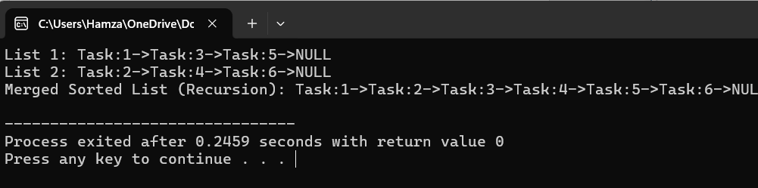
#include<iostream>
using namespace std;
class Node{
public:
int data;
Node* next;

Node(int value){
data=value;
next=NULL;
}
};
Node* head=NULL;
Node* tail=NULL;

void Insert(int value){
Node* newNode=new Node(value);
newNode->next=head;
head=newNode;
}

Node* MergeSortedLists(Node* L1,Node* L2){
if(L1==NULL){return L2 ;}
if(L2==NULL){return L2;}
if(L1->data<=L2->data){
L1->next=MergeSortedLists(L1->next,L2);
return L1;
}
else{
L2->next=MergeSortedLists(L1,L2->next);
return L2;
}
}
void Display(Node* head){
Node* temp=head;
do{
cout<<"Task:"<<temp->data<<"->";
temp=temp->next;
}while(temp!=NULL);
cout<<"NULL"<<endl;
}
int main() {
Node* L1 = new Node(1);
L1->next = new Node(3);
L1->next->next = new Node(5);

Node* L2 = new Node(2);
L2->next = new Node(4);
L2->next->next = new Node(6);

cout<<"List 1: ";
Display(L1);

cout<<"List 2: ";
Display(L2);

Node* mergedList=MergeSortedLists(L1, L2);

cout<<"Merged Sorted List (Recursion): ";
Display(mergedList);
}
Q7
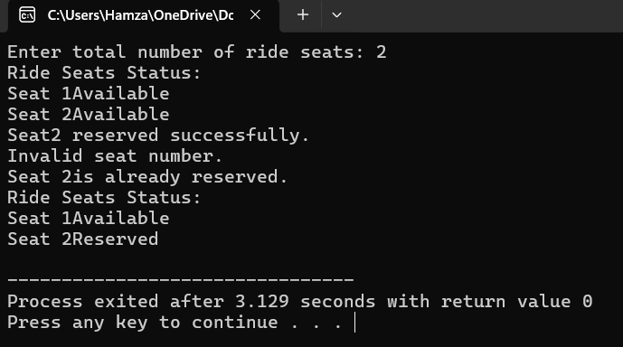
#include<iostream>
using namespace std;

class Node{
public:
int seatNo;
bool reserved;
Node* next;

Node(int num) {
seatNo=num;
reserved=false;
next=NULL;
}
};

class CircularLinkedList {
public:
Node* head;
int totalSeats;

CircularLinkedList(int n) {
head=NULL;
totalSeats=n;
createSeats(n);
}

void createSeats(int n) {
Node* prev=NULL;
for (int i=1;i<=n;i++) {
Node* newNode=new Node(i);
if(head==NULL) {
head=newNode;
} else
{
prev->next=newNode;
}
prev=newNode;
}
prev->next=head;
}

void reserveSeat(int num) {
Node* temp=head;
do
{
if(temp->seatNo==num) {
if (temp->reserved) {
cout<<"Seat "<<num<<"is already reserved."<<endl;
} else {
temp->reserved=true;
cout<<"Seat"<<num<<" reserved successfully."<<endl;
}
return;
}
temp=temp->next;
} while(temp!=head);
cout<<"Invalid seat number."<<endl;
}

void displaySeats() {
Node* temp = head;
if (head==NULL) {
cout<<"No seats available!" <<endl;
return;
}

cout<<"Ride Seats Status:"<<endl;
do {
cout<<"Seat "<<temp->seatNo;
if (temp->reserved){
cout<<"Reserved"<<endl;
}
else{
cout<<"Available"<<endl;
}
temp=temp->next;
} while(temp!=head);
}
};

int main() {
int n;
cout<<"Enter total number of ride seats: ";
cin>>n;

CircularLinkedList ride(n);

ride.displaySeats();

ride.reserveSeat(2);
ride.reserveSeat(4);
ride.reserveSeat(2);

ride.displaySeats();
}

Q8
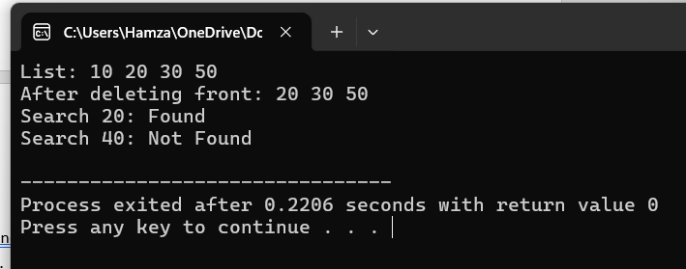
#include<iostream>
using namespace std;

class Node{
public:
int data;
Node* prev;
Node* next;
Node(){
data=0;
prev=NULL;
next=NULL;
}
Node(int value){
data=value;
prev=NULL;
next=NULL;
}
};

class DoublyLinkedList{
public:
Node* head =NULL;
Node* tail=NULL;

DoublyLinkedList(){
head=NULL;
tail=NULL;
}
void insertAtEnd(int value){
Node* newNode=new Node(value);
if(head==NULL){
head=tail=newNode;
}
else{
tail->next=newNode;
newNode->prev=tail;
tail=newNode;
}
}
void deleteAtFront(){
if(head==NULL){
cout<<"Empty list!"<<endl;
return;
}
Node* temp=head;
head=temp->next;
if(head !=NULL){
head->prev=NULL;
}
else{
tail=NULL;
}
delete temp;
}
bool search(int value){
Node* curr=head;
while(curr!=NULL){
if(curr->data==value){
return true;
curr=curr->next;
}
return false;
}
}
void display() {
if (head==NULL) {
cout<<"List is empty." << endl;
return;
}
Node* current=head;
while (current!=NULL) {
cout<<current->data<<" ";
current=current->next;
}
cout<<endl;
}
};
int main() {
DoublyLinkedList d;

d.insertAtEnd(10);
d.insertAtEnd(20);
d.insertAtEnd(30);
d.insertAtEnd(50);

cout<<"List: ";
d.display();

d.deleteAtFront();
cout<<"After deleting front: ";
d.display();

cout<<"Search 20: "<<(d.search(20) ? "Found":"Not Found")<<endl;
cout<<"Search 40: "<<(d.search(40) ? "Foud":"Not Found")<<endl;
return 0;
}

